17 Editors - Timeline
Timeline Editor 1
Time cursor 2
Keyframes 2
Markers 2
Viewport Navigation 3
Viewport navigation 3
Dope Sheet Context Menu 3
Copy 3
Paste 3
Paste Flipped 3
Keyframe Type 3
Handle Type 3
Interpolation Mode 4
Easing Mode 4
Insert Keyframes 4
Duplicate 4
Delete Keyframes 4
Mirror 4
Snap 4
Quick Favorites menu 4

Timeline Editor

The Timeline Editor is the editor type that contains playback and record elements and some further animation settings. The Timeline editor is part of five editor types that deals with your animation data.

The Dope sheet editor has several areas. Usually you will just see the header. To reveal the rest of it you have to pull the upper border of the timeline editor upwards.
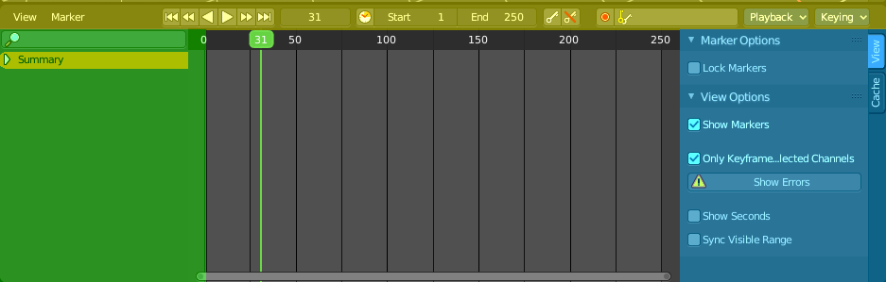
Header ( Green )
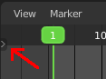
Channel list ( Green ). This channel list panel is hidden by default. You have to click at the small button up left to reveal it.

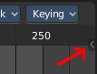
Sidebar ( Blue ). This Sidebar panel is hidden by default. You have to click at the small button up left to reveal it.
Viewport ( no color )
The header is divided into three parts too. Left tools and menus. Right Options. And in the middle the playback elements for the animation.

Menus ( Yellow )
Playback tools ( Green )
Options ( Blue )

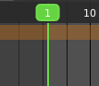
Time cursor
The Time Cursor is the green line. It is used to set and display the current time frame.

Keyframes
The timeline displays the keyframes. Different from the Dope Sheet it displays all keyframe type with one icon. A rhombus shape.

Markers
Markers are visible hints to denote frames with key points or significant events within an animation. A marker could mark a character’s animation starts, the position change of a camera, or a door that opens.
Markers can be added, deleted and renamed from the Marker menu. Once created they reside at the bottom of the viewport.
To select a marker click at it.
To move a marker click and drag.
The active marker is highlighted, and shows a dotted line upwards.
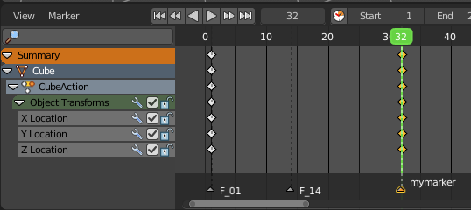

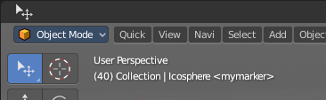
When a frame matches the marker position then the info string in the 3D view shows the name of this marker too.

Viewport Navigation

Navigation in the viewport happens by mouse or hotkeys. Some of them does not have a menu entry. And needs to be explained here.

Viewport navigation
Right mouse button moves the frame marker.
Clicking left at the number bar moves the frame marker.
Middle mouse button pans the view.
Holding ctrl + middle mouse button zooms the view.
Scroll Wheel zooms the view.
To drag a keyframe click at it and drag the mouse.

Dope Sheet Context Menu
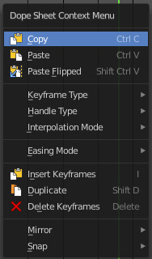
When you double right click into the timeline viewport then you will call the Dope Sheet context menu.

Copy
Copies the currently selected keyframe(s).

Paste
Pastes copied keyframe(s)

Paste Flipped
Pastes copied keyframe(s), but flipped.

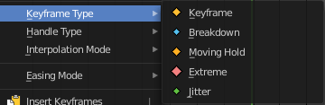
Keyframe Type
Recolor the currently selected keyframes.

Handle Type
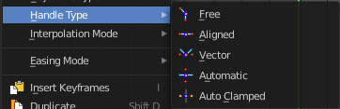
Set the handle type for the currently selected keyframes.
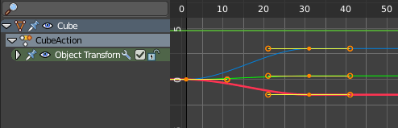
This is a feature for the Graph editor, where each curve point has its own handler with which you can influence the curve behavior. But the handler type also influences how the animation curve acts at the chosen keyframes. So it has its use in the dope sheet editor too.

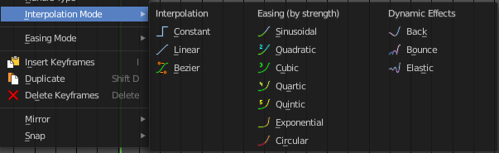
Interpolation Mode
The Interpolation mode defines how the curve acts from keyframe to keyframe. You can have a linear curve between two keyframes instead of a bent one for example.
The easing methods here in the interpolation mode menu are for the easing shape. There is also an easing menu where you can choose a easing method.

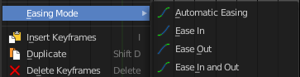
Easing Mode
The easing methods in the interpolation mode menu are for the easing shape. This menu allows you to choose an easing method.

Insert Keyframes
Insert a keyframe at the current position.

Duplicate
Duplicate the selected keyframe(s).

Delete Keyframes
Delete the selected keyframe(s).

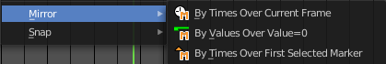
Mirror
Mirrors the animation by the given method.

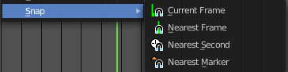
Snap
Snaps the selected keyframes by the given method.

Quick Favorites menu


When you right click at a menu or a button, then a right click menu will open. Tools have usually a Add to Quick Favorites menu entry.

The Quick Menu is empty by default. With Add to Quick favorites you can add this menu to the Quick menu.

In the 3D view we have a menu called Quick in the header, which shows this content then. In the Dope Sheet Editor you can just call it with its hotkey. Q. It has no regular menu entry here.

